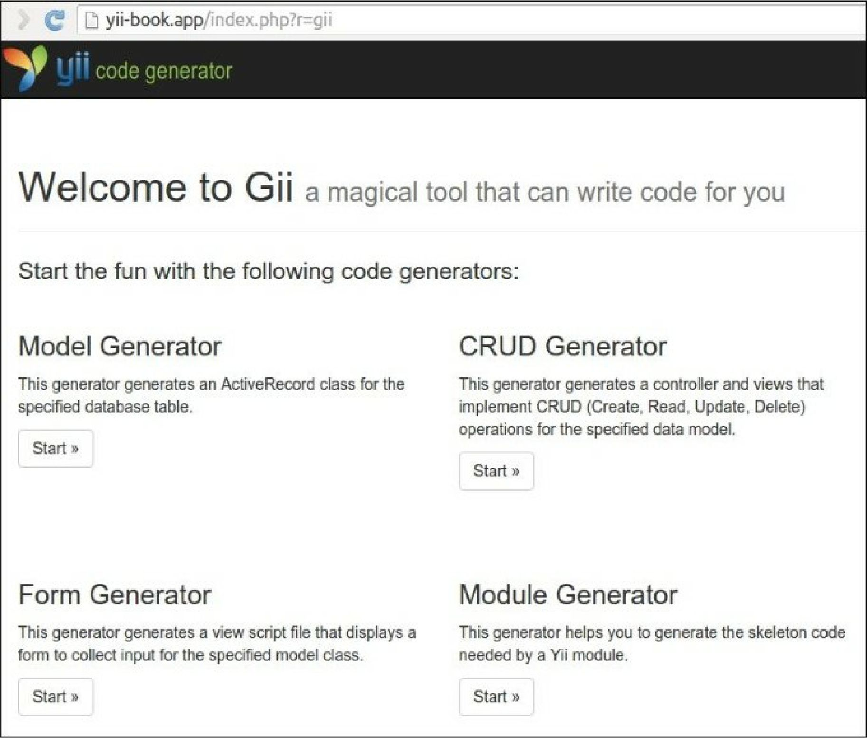

4. Click on the Model Generator button and type your table name and model name in the form: